Assignment on

Internet Technologies

Assignment Weightage & Type

60% Portfolio Coursework

Corse: BSc (Hons) CS & DF

Sem_2

UWE ID: 24030171

Student Name: MD Faisal

Assignment Date: Week_1

What is internet?

The internet is a global system of interconnected computer networks that use the Internet protocol suite (TCP/IP) to link devices worldwide. It is a network of networks that consists of private, public, academic, business, and government networks of local to global scope, linked by a broad array of electronic, wireless, and optical networking technologies.

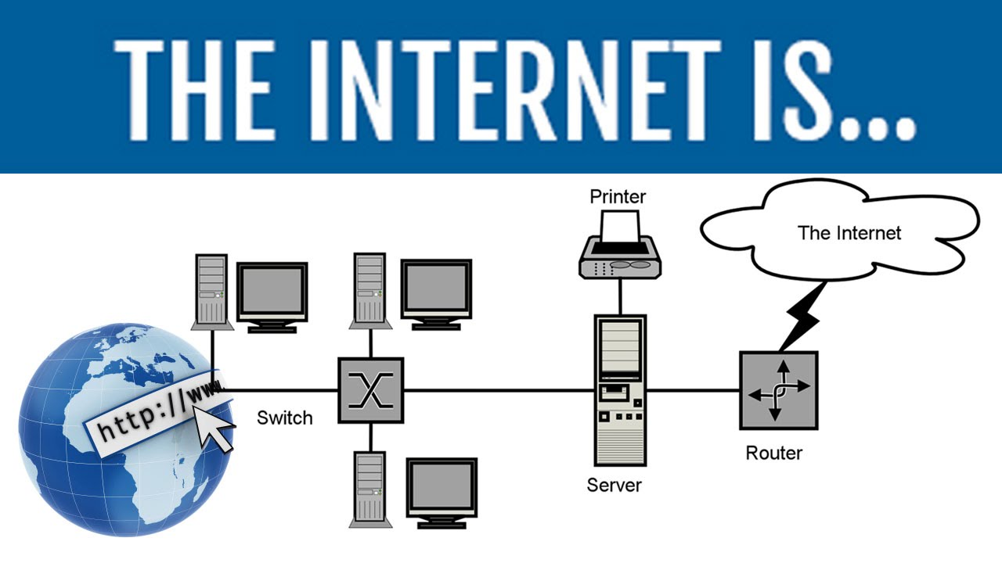

How did the Internet Developed?

* The Internet’s roots can be traced back to the 1960s.
* When the United States Department of Defense’s Advanced Research Projects Agency (ARPA) funded a project to create a network of computers that could communicate with each other.
* This project, known as ARPANET, was developed in the late 1960s and early 1970s by a team led by Vint Cerf and Bob Kahn.
* ARPANET is known as the forefather of internet.

Basic Services of Internet

The basic services of the internet include:

1. Communication:
2. Network Management Services:
3. Web Services:
4. File Transfer:
5. Information Retrieval:
6. E-commerce:
7. Email:
8. Instant Messaging:
9. Internet Telephony:

* Communication: The internet offers various communication services, such as email, instant messaging, internet telephony, VOIP, videoconferencing, and more. These services enable users to exchange information and stay in touch with others.



* Network Management Services: The internet provides network management services, which allow users to manage and control their network connections, including uploading and downloading files, accessing information, and more.

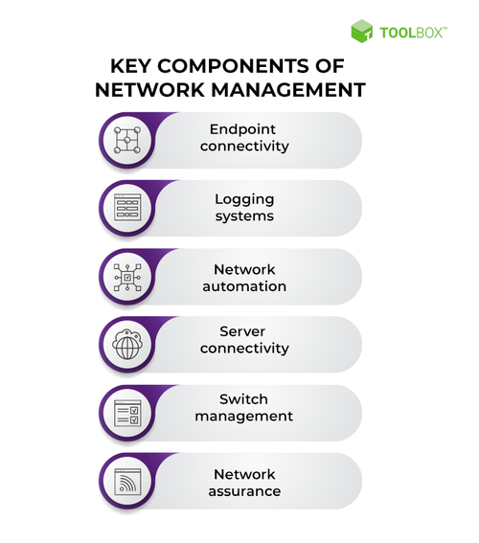

* Web Services: The internet offers a range of web services, including web hosting, web development, and e-commerce services, which enable users to create and manage their own websites and online businesses.
* File Transfer: The internet allows users to upload and download files, including documents, images, videos, and software, making it a convenient way to share information and collaborate with others.
* Information Retrieval: The internet provides access to a vast amount of information, including text, graphics, sound, and software, which can be accessed through various search engines and online directories.
* E-commerce: The internet enables online shopping, allowing users to purchase goods and services from anywhere in the world, 24/7.

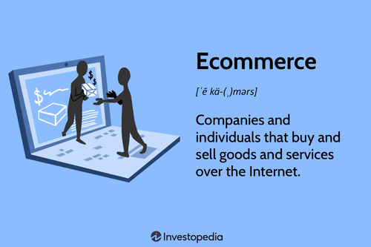

* Email: Email is a popular internet service that enables users to send and receive electronic messages, making it a convenient way to communicate with others.
* Instant Messaging: Instant messaging services, such as WhatsApp, Facebook Messenger, and Skype, allow users to send and receive instant messages, making it easy to stay in touch with friends and family.
* Internet Telephony: Internet telephony, also known as Voice over Internet Protocol (VoIP), allows users to make voice calls over the internet, reducing the need for traditional phone lines.

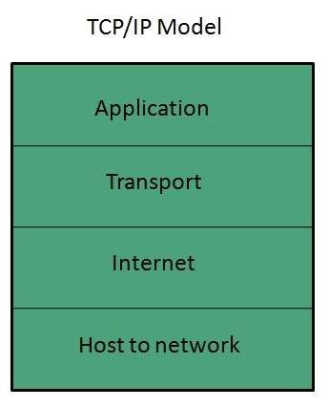

Uses of the Internet?

The uses of internets are given below:

* Communication
* Email:
* Social Media:
* Search Engines:
* Online Courses:
* E-Learning Platforms:
* Online Libraries
* Online Games:
* E-commerce:
* Telemedicine:
* Online Booking:
* Other Uses:

Network:

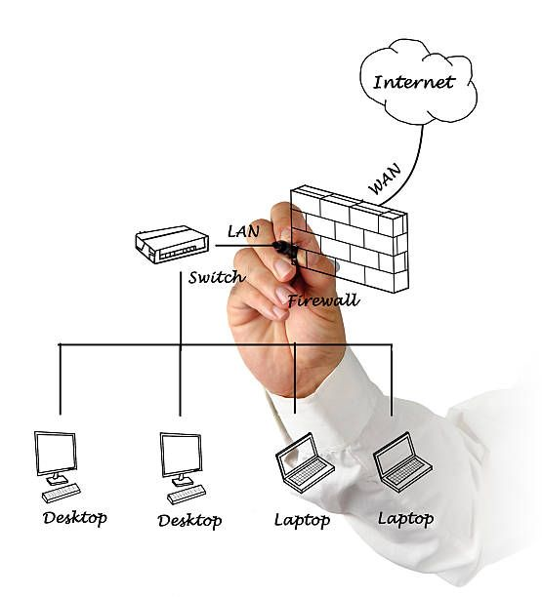

Internet Registries

Internet number resources are distributed globally according to a hierarchical registry system

The Internet Assigned Numbers Authority (department of ICANN) which oversees global IP address allocation, autonomous system number allocation, root zone management in the Domain Name System, media types, and other Internet Protocol-related Services

A regional Internet registry (RIR) is an organization that manages the allocation and registration of Internet Number Resource (IP Address) Internet Registries

A Regional Internet Registry (RIR) is an organization that manages the allocation and registration of Internet Number Resource (IP Address)

The graph below shows how Internet number resources are distributed from the central IANA-managed pool to the five Regional Internet Registries and then onto their Members (Local Internet Registries, or LIRs)

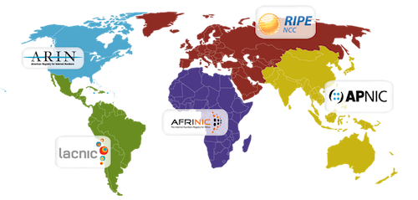

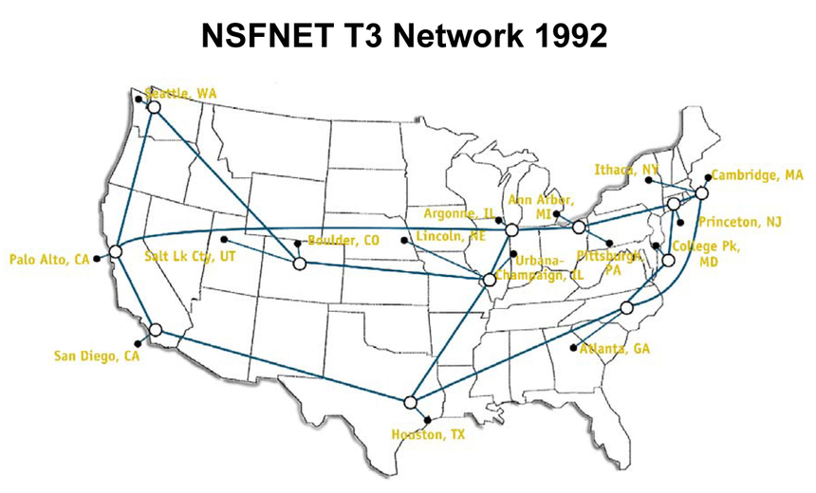

Domain Names

Domain names are used to identify one or more IP Address EX: [www.google.com](http://www.google.com)

Domain names are used in URLs to identify particular Web Pages.

Every domain name has a suffix that indicates which Top Level Domain(TLD) it belongs to.

For example: ◦ com - commercial business ◦ net - Network organizations ◦ gov - Government agencies ◦ edu - Educational institutions ◦ org - Organizations (nonprofit) ◦ mil – Militar.

DNS

The Domain Name System (DNS) is the phonebook of the Internet. Humans access information online through [domain names](https://www.cloudflare.com/learning/dns/glossary/what-is-a-domain-name/), like nytimes.com or espn.com. Web browsers interact through [Internet Protocol (IP)](https://www.cloudflare.com/learning/network-layer/internet-protocol/) addresses. DNS translates domain names to [IP addresses](https://www.cloudflare.com/learning/dns/glossary/what-is-my-ip-address/) so browsers can load Internet resources.



URL

A URL (Uniform Resource Locator) is the address of a unique resource on the internet. It is one of the key mechanisms used by browsers to retrieve published resources, such as HTML pages, CSS documents, images, and so on.

URL stands for Uniform Resource Locator. A URL is a formatted text string used by Web browsers, email clients and other software to identify a network resource on the Internet.

Network resources are files that can be plain Web pages, other text documents, graphics, or programs. URL strings consist of three parts (substrings): ◦ network protocol ◦ host name or address ◦ file or resource location

These substrings are separated by special characters as follows: protocol :// host / location

URL Protocol

The 'protocol' substring defines a network protocol to be used to access a resource. These strings are short names followed by the three characters '://' (a simple naming convention to denote a protocol definition). Typical URL protocols include http://, ftp://, and <mailto://>.

URL Host

The 'host' substring identifies a computer or other network device. Hosts come from standard Internet databases such as DNS and can be names or IP addresses. For example, compnetworking.about.com is the host for this Web page.

URL Location

The 'location' substring contains a path to one specific network resource on the host. Resources are normally located in a host directory or folder.

For example, /Category/Products/page1.html is the location of this Web page including two subdirectories and the file name

. When the location element is omitted such as in http://example.com/, the URL conventionally points to the root directory of the host and often a home page (like 'index.html').



INTERNET DIAGRAM



What is www?

The World Wide Web (WWW) is a system of interconnected public webpages accessible through the Internet. It is a hypertext-based information system that allows users to access and share information over the Internet using a web browser.

History of www?

The World Wide Web (WWW) was first conceived in 1989 by British computer scientist Sir Tim Berners-Lee while working at CERN, the European particle physics laboratory in Switzerland. Initially, Berners-Lee wanted to find a way to facilitate the sharing of information among scientists and researchers. He proposed a system of interlinked hypertext documents that could be accessed via the internet.

* 1989: Tim Berners-Lee proposes the World Wide Web concept
* 1990: Berners-Lee writes the first web server software and creates the first web browser
* 1991: The first web page is launched
* 1992: The WWW software at CERN matures, and Berners-Lee makes the source code available to the public
* 1993: Berners-Lee releases the source code for the world’s first web browser and editor
* 1994: The First International World Wide Web conference is held at CERN.

ISP

Short for Internet Service Provider,

A company that provides Internet services, including personal and business access to the Internet

More recently, wireless Internet service providers or WISPs have emerged that offer Internet access through wireless LAN or wireless broadband networks.

In addition to basic connectivity, many ISPs also offer related Internet services like email, Web hosting and access to software tools.

Web Server

Web servers are computers that deliver (serves up) Web pages.

Every Web server has an IP address and possibly a domain name.

For example, if you enter the URL http://www.thebritishcollege.edu.np in your browser, this sends a request to the Web server whose domain name is thebritishcollege.edu.np

The server then fetches the index or home page and sends it to your browser

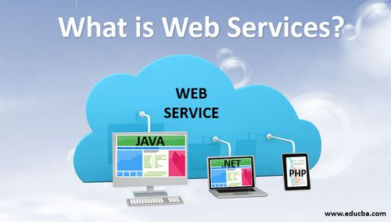

Email

Email, short for Electronic Mail, is a method of sending and receiving messages electronically through a network. It allows users to send and receive messages, files, and other digital content from one computer to another. Emails are a fast, inexpensive, and accessible way to communicate for both personal and professional purposes.

Key Components of an Email:

* Subject: Provides a quick glimpse of the email content.
* From: Displays the sender’s email address.
* To: Displays the recipient’s email address.
* Date and time: The date and time that the email was received are as per the recipient’s time zone.
* Recipient: Displays the recipient’s name.
* Reply-to: When the recipient clicks the Reply button in the received email, the To field gets filled automatically based on the email ID available in the Reply-to field.
* Carbon copy (Cc): This field is used whenever the sender wants to send a copy of the email to other users.
* Blind carbon copy (Bcc): The email address entered in the Bcc field will not be visible to those users who were added in the To and Cc fields.
* Attachments: Contains those files which the sender attaches in support of the content in the body of the email.

How Email Works:

Emails travel across different time zones within a snap of a finger, making it an effective mode of communication for both personal and professional purposes. Users can send emails from anywhere as long as they have an internet connection, which is typically provided by an internet service provider.

Types of E-mail (Web vs. Client)

E-mail is a basic service that allows you to send messages from one user to another. Basically there are two types of email services.

Client-based Email:

Username: This is usually just the first part of your email address.

Password: Your password corresponding with your Username.

Email Address: A valid email address looks like this: [user1@wlink.com.np](mailto:user1@wlink.com.np).

POP3 Server Address: This is the address we need to configure to get your incoming mail. It typically looks like this: mail.your-isp.net

SMTP Server Address: This is the address we need to configure to get your outgoing mail. It typically looks like this: smtp.your-isp.net or mail.your-isp.net

If you configure the client program properly, you can send and receive email messages through your client program from your computer.

Web-based Email

To utilize the web-based email services, first you need to register to get a free account.

To start the process, you have to log-in with a USERNAME/LOGIN ID and PASSWORD.

Then you have full control to send, receive, forward, reply and delete your email files. Some of the well-known free web-based email services are: ◦ Yahoo.com ◦ Gmail.com ◦ MSN.com

The advantage of web-based email services is that you can check your mail from any computer that is connected to the internet.

All of your email files are stored on the web-based server.

A typical mail environment

A typical mail environment is a set of variables that define how email is handled and processed within a system. These variables can be customized by system administrators and users to suit their specific needs.

Simple Mail Transfer Protocol (SMTP)

Internet standard for electronic mail (e-mail) transmission.

First defined by RFC 821 in 1982, it was last updated in 2008 with the Extended SMTP additions by RFC 5321 - which is the protocol in widespread use today.

SMTP by default uses TCP port 25.

The protocol for mail submission is the same, but uses port 587. SMTP connections secured by SSL, known as SMTPS, default to port 465.

While electronic mail servers and other mail transfer agents use SMTP to send and receive mail messages, user-level client mail applications typically use SMTP only for sending messages.

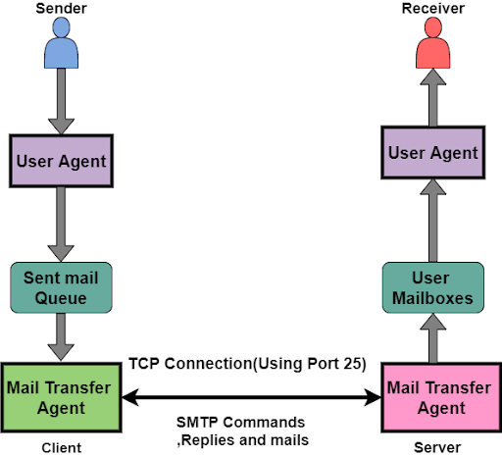

Post Office Protocol

Protocol to transfer e-mail messages from mailbox to local computer.

User invokes a POP3 client, which creates a TCP connection to a POP3 server on the mailbox computer.

Computer with permanent mailbox must run 2 servers- ◦ SMTP (Accepts mail sent to user) ◦ POP3 (Allows to extract messages from mailbox).

Filezilla

The free FTP solution.

Both a client and a server are available.

FileZilla is open source software distributed free of charge under the terms of the GNU General Public License

For more info : <https://filezilla-project.org/>

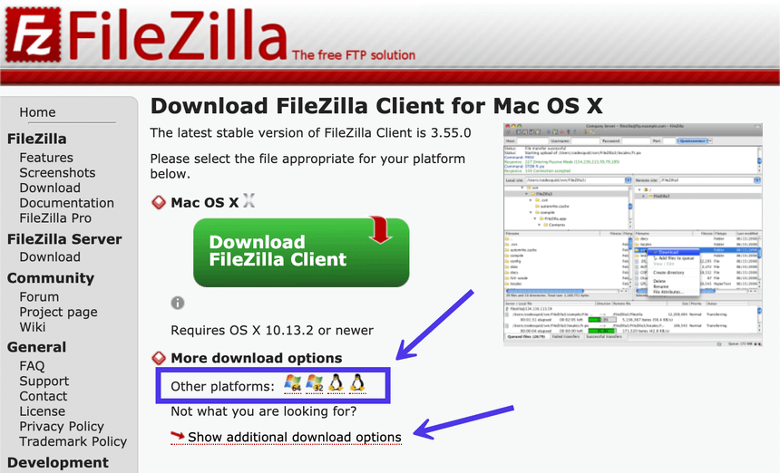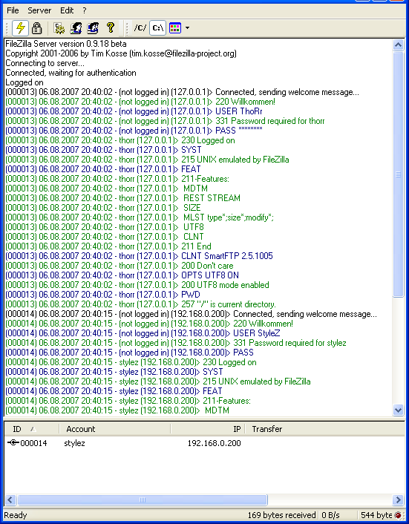

HTTP

Short for Hypertext Transfer Protocol, the underlying protocol used by the World Wide Web.

HTTP defines how messages are formatted and transmitted, and what actions Web servers and browsers should take in response to various commands.

For example, when you enter a URL in your browser, this actually sends an HTTP command to the Web server directing it to fetch and transmit the requested Web page.

Language of the Web ◦ protocol used for communication between web browsers and web servers

TCP port 80 (443 secure.

HTTP – methods

◦ GET

retrieve a URL from the server

simple page request

run a CGI program

run a CGI with arguments attached to the URL

◦ POST

preferred method for forms processing

run a CGI program

parameterized data in sysin

more secure and private

HTTP Request Packets

Sent from client to server

Consists of HTTP header

content type / mime type

content length

user agent - browser issuing request

content types user agent can handle

